EXERCISE 2
1. Understanding Asymptotic Notation
What is Big O Notation?
Big O notation is a mathematical way to describe the performance of an algorithm as the input size (n) grows. It helps measure how the running time or memory usage increases with larger datasets.
Common complexities:
Complexity | Notation | Example
Constant | O(1) | Accessing an array element
Logarithmic | O(log n) | Binary Search
Linear | O(n) | Linear Search
Quadratic | O(n²) | Nested loops

Search Operation Scenarios:-
Best-Case Scenario
The best-case scenario occurs when the search operation finds the required element on the very first comparison, resulting in the least amount of time and effort.
Example:
If the array is [101, 102, 103, 104, 105] and we search for 101, a linear search finds it immediately at the first position.
Average-Case Scenario
The average-case scenario occurs when the element is located somewhere in the middle of the dataset. The search algorithm performs a moderate number of comparisons before finding the element.
Example:
If the array is [101, 102, 103, 104, 105] and we search for 103, a linear search checks a few elements before finding the target in the middle of the array.
Worst-Case Scenario
The worst-case scenario occurs when the element is at the last position of the dataset or is not present at all. The search algorithm must examine the maximum number of elements before completing the search.
Example:
If the array is [101, 102, 103, 104, 105] and we search for 105, a linear search checks every preceding element before finding it. Similarly, searching for 106 (which is not in the array) requires checking all elements before concluding that the element does not exist.
2.Setup
Product Class(Java)
CODE
public class Product {
private int productId;
private String productName;
private String category;

public Product(int productId, String productName, String category) {
this.productId = productId;
this.productName = productName;
this.category = category;
}

public int getProductId() {
return productId;
}

public String getProductName() {
return productName;
}

public String getCategory() {
return category;
}

@Override
public String toString() {
return "Product ID: " + productId +
", Name: " + productName +
", Category: " + category;
}
}
3.Implementation
Linear Search
CODE
public static Product linearSearch(Product[] products, int targetId) {
for (Product product : products) {
if (product.getProductId() == targetId) {
return product;
}
}
return null;
}
Binary Search
CODE
public static Product binarySearch(Product[] products, int targetId) {
int left = 0;
int right = products.length - 1;

while (left <= right) {
int mid = left + (right - left) / 2;

if (products[mid].getProductId() == targetId) {
return products[mid];
}

if (products[mid].getProductId() < targetId) {
left = mid + 1;
} else {
right = mid - 1;
}
}

return null;
}
Example Usage
CODE
public class SearchDemo {

public static void main(String[] args) {

Product[] products = {
new Product(101, "Laptop", "Electronics"),
new Product(102, "Phone", "Electronics"),
new Product(103, "Shoes", "Fashion"),
new Product(104, "Watch", "Accessories"),
new Product(105, "Bag", "Fashion")
};

Product result1 = linearSearch(products, 104);
System.out.println("Linear Search Result: " + result1);

Product result2 = binarySearch(products, 104);
System.out.println("Binary Search Result: " + result2);
}

public static Product linearSearch(Product[] products, int targetId) {
for (Product product : products) {
if (product.getProductId() == targetId) {
return product;
}
}
return null;
}

public static Product binarySearch(Product[] products, int targetId) {
int left = 0;
int right = products.length - 1;

while (left <= right) {
int mid = left + (right - left) / 2;

if (products[mid].getProductId() == targetId) {
return products[mid];
}

if (products[mid].getProductId() < targetId) {
left = mid + 1;
} else {
right = mid - 1;
}
}

return null;
}
}

class Product {
private int productId;
private String productName;
private String category;

public Product(int productId, String productName, String category) {
this.productId = productId;
this.productName = productName;
this.category = category;
}

public int getProductId() {
return productId;
}

@Override
public String toString() {
return "Product ID: " + productId +
", Name: " + productName +
", Category: " + category;
}
}
OUTPUT
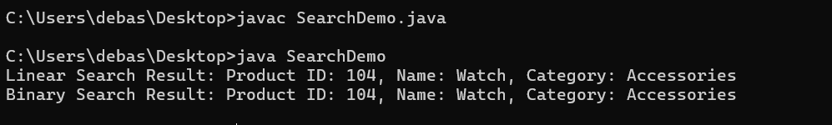
4.Analysis
Time Complexity Comparison
Algorithm | Best Case | Average Case | Worst Case
Linear Search | O(1) | O(n) | O(n)
Binary Search | O(1) | O(log n) | O(log n)

Which Algorithm is Better?
Binary Search is more suitable for an e-commerce platform even though we need to sort the array or list first (in this case the products say by productid) because:
- Product databases can contain thousands or millions of products.
- Binary search significantly reduces search time.
- It scales better as the product catalog grows.
- Search operations are frequent in e-commerce applications.

